**Lab sheet 02**

**Java Servlet**

**Task 1: Simple Servlet - Display Static Message**

1. **Create a Java Servlet (DisplayMessageServlet)** that outputs a static message.

import java.io.IOException;

import java.io.PrintWriter;

import javax.servlet.ServletException;

import javax.servlet.annotation.WebServlet;

import javax.servlet.http.HttpServlet;

import javax.servlet.http.HttpServletRequest;

import javax.servlet.http.HttpServletResponse;

@WebServlet(urlPatterns = {"/DisplayMessageServlet"})

public class DisplayMessageServlet extends HttpServlet {

protected void processRequest(HttpServletRequest request, HttpServletResponse response)

throws ServletException, IOException {

response.setContentType("text/html;charset=UTF-8");

try (PrintWriter out = response.getWriter()) {

out.println("<html><body>");

out.println("<h1>Welcome to the Java Servlet Lab!</h1>");

out.println("</body></html>");

}

}

}

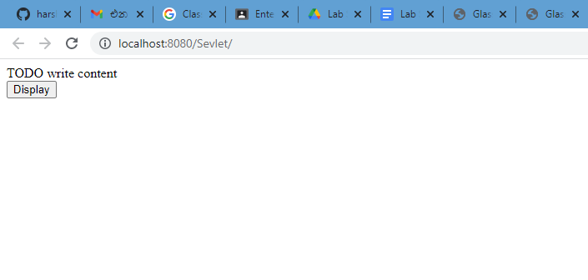

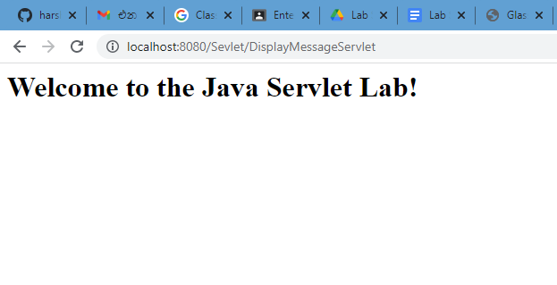

**2. Create a servlet that receives user input from an HTML form and displays it back to the user**.

* **Create an HTML form to collect the user's name.**

<html>

<head><title>Input Form</title></head>

<body>

<form action="getUserInput" method="POST">

Name: <input type="text" name="username" required><br>

<input type="submit" value="Submit">

</form>

</body>

</html>Top of Form

Bottom of Form

* **Create a Servlet (GetUserInputServlet) to handle the form submission and display the user's name.**

import java.io.IOException;

import java.io.PrintWriter;

import javax.servlet.ServletException;

import javax.servlet.annotation.WebServlet;

import javax.servlet.http.HttpServlet;

import javax.servlet.http.HttpServletRequest;

import javax.servlet.http.HttpServletResponse;

@WebServlet(urlPatterns = {"/getUserInput"})

public class GetUserInputServlet extends HttpServlet {

protected void processRequest(HttpServletRequest request, HttpServletResponse response)

throws ServletException, IOException {

response.setContentType("text/html;charset=UTF-8");

try (PrintWriter out = response.getWriter()) {

/* TODO output your page here. You may use following sample code. */

out.println("<!DOCTYPE html>");

out.println("<html>");

out.println("<head>");

out.println("<title>Servlet GetUserInputServlet</title>");

out.println("</head>");

out.println("<body>");

out.println("<h1>Servlet GetUserInputServlet at " + request.getContextPath() + "</h1>");

out.println("</body>");

out.println("</html>");

}

}

@Override

protected void doGet(HttpServletRequest request, HttpServletResponse response)

throws ServletException, IOException {

processRequest(request, response);

}

@Override

protected void doPost(HttpServletRequest request, HttpServletResponse response)

throws ServletException, IOException {

String username = request.getParameter("username");

response.setContentType("text/html");

PrintWriter out = response.getWriter();

out.println("<html><body>");

out.println("<h1>Hello, " + username + "!</h1>");

out.println("</body></html>");

processRequest(request, response);

}

@Override

public String getServletInfo() {

return "Short description";

}// </editor-fold>

}

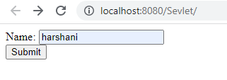

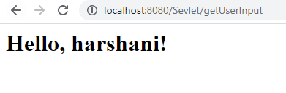

**3. Create a servlet that receives multiple user inputs from a form, performs a calculation, and displays the result.**

**-method1-**

<!DOCTYPE html>

<html>

<head><title>Sum Calculator</title></head>

<body>

<form action="calculateSum" method="POST">

First Number: <input type="number" name="num1" required><br>

Second Number: <input type="number" name="num2" required><br>

<input type="submit" value="Calculate Sum">

</form>

</body>

</html>

import java.io.IOException;

import java.io.PrintWriter;

import javax.servlet.ServletException;

import javax.servlet.annotation.WebServlet;

import javax.servlet.http.HttpServlet;

import javax.servlet.http.HttpServletRequest;

import javax.servlet.http.HttpServletResponse;

@WebServlet("/calculateSum")

public class CalculateSumServlet extends HttpServlet {

protected void doPost(HttpServletRequest request, HttpServletResponse

response)

throws ServletException, IOException {

int num1 = Integer.parseInt(request.getParameter("num1"));

int num2 = Integer.parseInt(request.getParameter("num2"));

int sum = num1 + num2;

response.setContentType("text/html");

PrintWriter out = response.getWriter();

out.println("<html><body>");

out.println("<h1>The sum of " + num1 + " and " + num2 + " is: " + sum

+ "</h1>");

out.println("</body></html>");

}

}

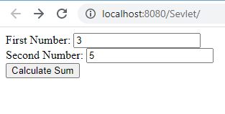

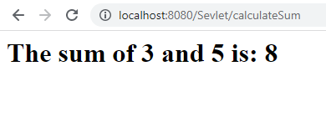

**-Method 2-**

<html>

<head>

<title>TODO supply a title</title>

<meta charset="UTF-8">

<meta name="viewport" content="width=device-width, initial-scale=1.0">

</head>

<!DOCTYPE html>

<title>Sum Calculator</title></head>

<body>

<form action="calculateSum" method="POST">

First Number: <input type="number" name="num1" required><br>

Second Number: <input type="number" name="num2" required><br>

<input type="submit" value="Calculate Sum">

</form>

</body>

</html>

import java.io.IOException;

import java.io.PrintWriter;

import javax.servlet.ServletException;

import javax.servlet.annotation.WebServlet;

import javax.servlet.http.HttpServlet;

import javax.servlet.http.HttpServletRequest;

import javax.servlet.http.HttpServletResponse;

@WebServlet("/calculateSum")

public class CalculateSumServlet extends HttpServlet {

protected void doPost(HttpServletRequest request, HttpServletResponse

response)

throws ServletException, IOException {

int num1 = Integer.parseInt(request.getParameter("num1"));

int num2 = Integer.parseInt(request.getParameter("num2"));

int sum = num1 + num2;

response.setContentType("text/html");

PrintWriter out = response.getWriter();

out.println("<!DOCTYPE html>");

out.println("<html>");

out.println("<head>");

out.println("<title>Servelet calculateSumServelet</title>");

out.println("</head>");

out.println("<body>");

out.println("<h1> Calculate Sum </h1>");

out.println("<h3> First User Input :" + num1 +"</h3>");

out.println("<h3> Second User Input :" + num2 +"</h3>");

out.println("<h1> Answer :" + sum +"</h1>");

out.println("</body>");

out.println("</html>");

}

}

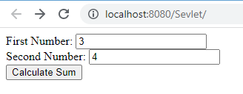

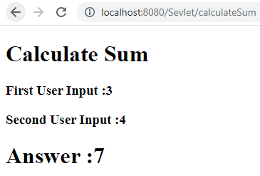Top of Form

Bottom of Form